**Python Advance Assignment 2**

Ans 1. An array of arrays of arrays is a three-dimensional (3D) array.

A multi-dimensional array in programming might have two, three, or even more dimensions.

program's maximum size may vary depending on the compiler being used.

Example :

The exam results for a class of six students who took five exams can be stored in a three-dimensional array.

2) There are two components to every exam: multiple-choice and essay.

3) Double [] [] [] [] scores are equal to or greater than new double [6] [5] [2] scores.

Ans 2.

Series can only contain single list with index, whereas dataframe can be made of more than one series or we can say that a dataframe is a collection of series that can be used to analyse the data.

Ans 3.

In order to prepare datasets for analysis, Pandas provides a wide variety of built-in functions. You can fill in missing numbers, delete blank rows and columns, and rename categories to make the dataset easier to read.

Ans 4. 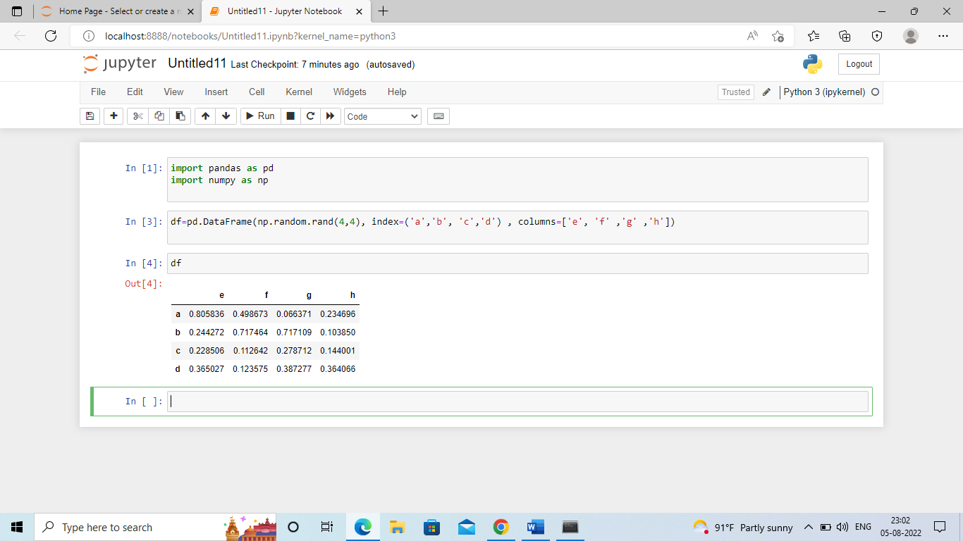

Ans 5.

Pandas uses the plot() method to create diagrams. For example……

